IIT JAMMU SUMMER SCHOOL 2026
IoT & Drones Program

Assignment
Fundamentals of Drones and UAV Systems

Name: Ansh Andotra
Course: IoT & Drones Program
Institution: IIT Jammu Summer School 2026
Date: July 30, 2026

Q1. What is a drone (UAV)? Definition, history, and evolution. [5 Marks]
Definition
A drone, technically known as an Unmanned Aerial Vehicle (UAV), is an aircraft that operates without a human pilot physically on board. It is either guided remotely by a human operator using a radio transmitter, or it flies autonomously using an onboard flight controller, GPS, and sensors that execute a pre-programmed mission. The UAV, together with its ground control station, communication link, and payload (camera, sensors, cargo, etc.), is collectively called an Unmanned Aircraft System (UAS).
History
- 1849: Austrian forces launched unmanned incendiary balloons against Venice - one of the earliest recorded unmanned aerial attacks.
- 1918: The Kettering “Bug”, developed for the US Army during World War I, was the first practical powered unmanned aerial torpedo.
- 1930s–40s: Radio-controlled target drones such as the British “Queen Bee” and the American “Radioplane OQ-2” were used for anti-aircraft gunnery practice; the term “drone” is widely believed to derive from the Queen Bee.
- 1950s–60s: Cold-War reconnaissance UAVs such as the Ryan Firebee allowed surveillance without risking a pilot's life.
- 1973 & 1982: Israeli forces pioneered real-time tactical UAV reconnaissance during Middle-East conflicts, proving the operational value of drones.
- 1990s–2000s: GPS-guided military UAVs such as the Predator and Global Hawk enabled long-endurance surveillance and precision strike missions.
- 2010s–present: Miniaturised MEMS sensors, brushless motors, Li-Po batteries and inexpensive flight controllers (e.g., the DJI Phantom, 2013) triggered the commercial and consumer drone revolution.
Evolution
Drones have evolved from crude balloon and kite-based weapons, to radio-controlled military target aircraft, to GPS-guided autonomous reconnaissance platforms, to today's AI- and computer-vision-enabled multirotor and fixed-wing systems used in agriculture, delivery, mapping, inspection and entertainment. The trend continues toward autonomous drone swarms, Beyond-Visual-Line-of-Sight (BVLOS) operation, and electric VTOL aircraft for urban air mobility.

Q2. List at least five real-world applications of drones. [5 Marks]
Precision Agriculture: Multispectral/thermal aerial imaging to monitor crop health, along with automated pesticide, fertiliser and seed spraying, saving time and reducing chemical wastage.
Package & Medical Delivery: Companies such as Zipline use drones to deliver blood and vaccines to remote clinics, while services like Amazon Prime Air aim to deliver small parcels directly to homes.
Aerial Photography & Cinematography: Gimbal-stabilised cameras on drones capture film shots, real-estate walkthroughs and event coverage that were previously only possible with a helicopter.
Disaster Management & Search-and-Rescue: Thermal cameras help locate survivors in rubble or wilderness, and rapid aerial surveys assess flood, earthquake or fire damage safely.
Infrastructure Inspection: Drones inspect power lines, wind-turbine blades, bridges and pipelines closely without scaffolding, shutdowns, or risk to human inspectors.
Surveying, Mapping & GIS: Photogrammetry from overlapping aerial photos builds orthomosaics and 3D terrain models used in construction, mining and urban planning.

Q3. Differentiate between the following: [10 Marks]
(a) UAV vs. Drone
Aspect | UAV (Unmanned Aerial Vehicle) | Drone
Full form / origin | Formal engineering & aviation term | Popular / informal term for the same object
Usage | Used officially by regulators (e.g., DGCA, FAA) and the defence industry | Used casually in everyday language and media
Scope | Covers all unmanned aircraft — fixed-wing, rotary, blimps, of any size | Usually refers to small multirotor aircraft
Word origin | Derived from “aerial” + “vehicle” terminology | Believed to come from the WWII “Queen Bee” target aircraft, whose hum resembled a male bee (drone)

(b) Fixed-wing vs. Multirotor Drones
Aspect | Fixed-wing | Multirotor
Lift generation | Airflow over a rigid wing; needs continuous forward airspeed | Multiple spinning rotors; can generate lift while stationary
Take-off / landing | Needs a runway, catapult or net | Vertical Take-Off and Landing (VTOL)
Hovering | Not possible | Yes — can hold a fixed position in the air
Endurance / range | Long (hours), aerodynamically efficient | Shorter (typically 20–40 minutes), power-hungry
Typical use | Mapping large areas, long-range surveillance | Photography, inspection, delivery in tight spaces

(c) Quadcopter vs. Hexacopter
Aspect | Quadcopter | Hexacopter
Number of motors/rotors | 4 | 6
Redundancy | Single motor failure usually causes a crash | Can often survive one motor failure and land safely
Payload capacity | Lower | Higher
Cost & complexity | Simpler, cheaper, lighter wiring | More expensive; extra ESCs and wiring
Agility | Lighter and more agile | More stable but less agile due to added weight

Q4. Explain how a quadcopter flies (lift, thrust, gravity, drag, propeller rotation, CW/CCW motors). [10 Marks]
Each propeller is shaped like an airfoil. As the brushless motor spins it at high RPM, the blade accelerates a column of air downward. By Newton's Third Law, the air being pushed down produces an equal and opposite reaction force pushing the propeller — and therefore the drone — upward. This upward reaction force is called Thrust (T).
Four forces acting on a quadcopter
- Lift / Thrust — the combined upward force produced by all four propellers.
- Weight (Gravity) — the downward force equal to mass × g, acting at the drone's centre of gravity.
- Drag — air resistance that opposes whichever direction the drone is moving.
- Thrust vector component — when the frame tilts, part of the thrust is redirected horizontally to move the drone forward/back/sideways.
When total thrust equals weight, the drone hovers. When thrust exceeds weight, it climbs; when thrust is less than weight, it descends.
Clockwise (CW) / Counter-clockwise (CCW) motors
In a standard “X” configuration, diagonally-opposite motors spin in the same direction — for example, front-left and rear-right spin counter-clockwise while front-right and rear-left spin clockwise. This pairing is essential: every spinning propeller also creates a reaction torque on the airframe, opposite to its own spin direction (again by Newton's Third Law). If all four motors spun the same way, these reaction torques would add up and spin the whole airframe out of control. By using two CW and two CCW motors, the reaction torques cancel out during hover, keeping the frame stable in yaw. Deliberately unbalancing the speed of the CW pair versus the CCW pair is exactly how the drone is made to rotate (yaw) in a controlled way.
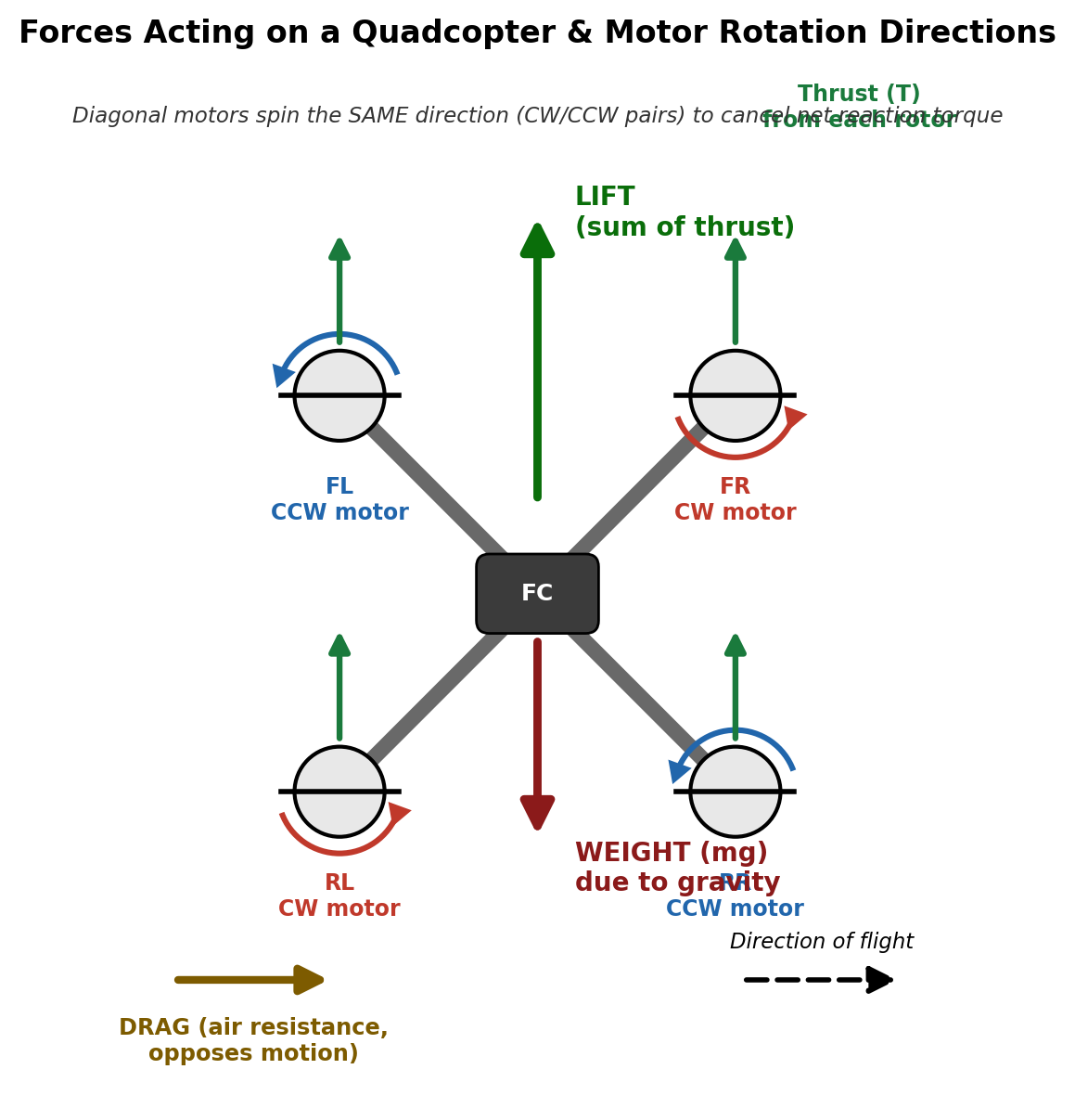
Fig. 4.1 — Forces acting on a quadcopter and CW/CCW motor rotation

Q5. Explain how a drone performs take-off, landing, hovering, and directional movement. [10 Marks]
Hover: All four motors spin at equal RPM, producing total thrust exactly equal to the drone's weight. With net force zero, the drone stays at a fixed position and altitude.
Take-off: The flight controller raises all four motor speeds equally so that thrust exceeds weight, producing a net upward force that lifts the drone off the ground.
Landing: All four motor speeds are reduced equally so that weight momentarily exceeds thrust, producing a small, controlled net downward force for a gentle descent.
Move Forward: The rear motors spin slightly faster than the front motors. This pitches the nose down, tilting the net thrust vector forward so part of it pulls the drone forward while the rest still supports its weight.
Move Backward: The front motors spin faster than the rear motors, pitching the tail down and redirecting part of the thrust vector backward.
Move Left: The right-side motors spin faster than the left-side motors, rolling the drone to the left and tilting thrust leftward.
Move Right: The left-side motors spin faster than the right-side motors, rolling the drone to the right and tilting thrust rightward.
Rotate (Yaw): One diagonal motor pair (say, the CW pair) is sped up while the other diagonal pair (CCW) is slowed by an equal amount. Total thrust — and therefore altitude — stays constant, but the resulting unbalanced reaction torque rotates the drone about its vertical axis.
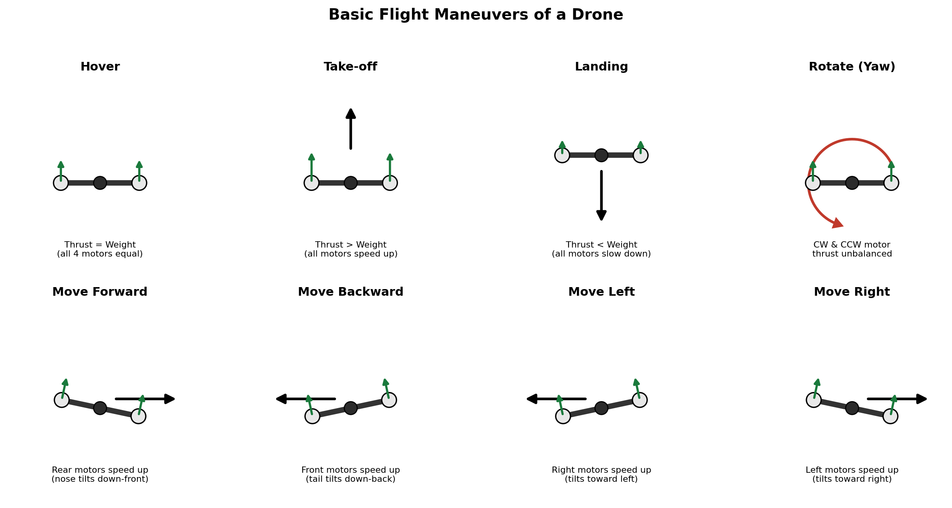
Fig. 5.1 — Basic flight maneuvers of a drone

Q6. Draw a labeled block diagram of a drone and explain the function of each component. [10 Marks]
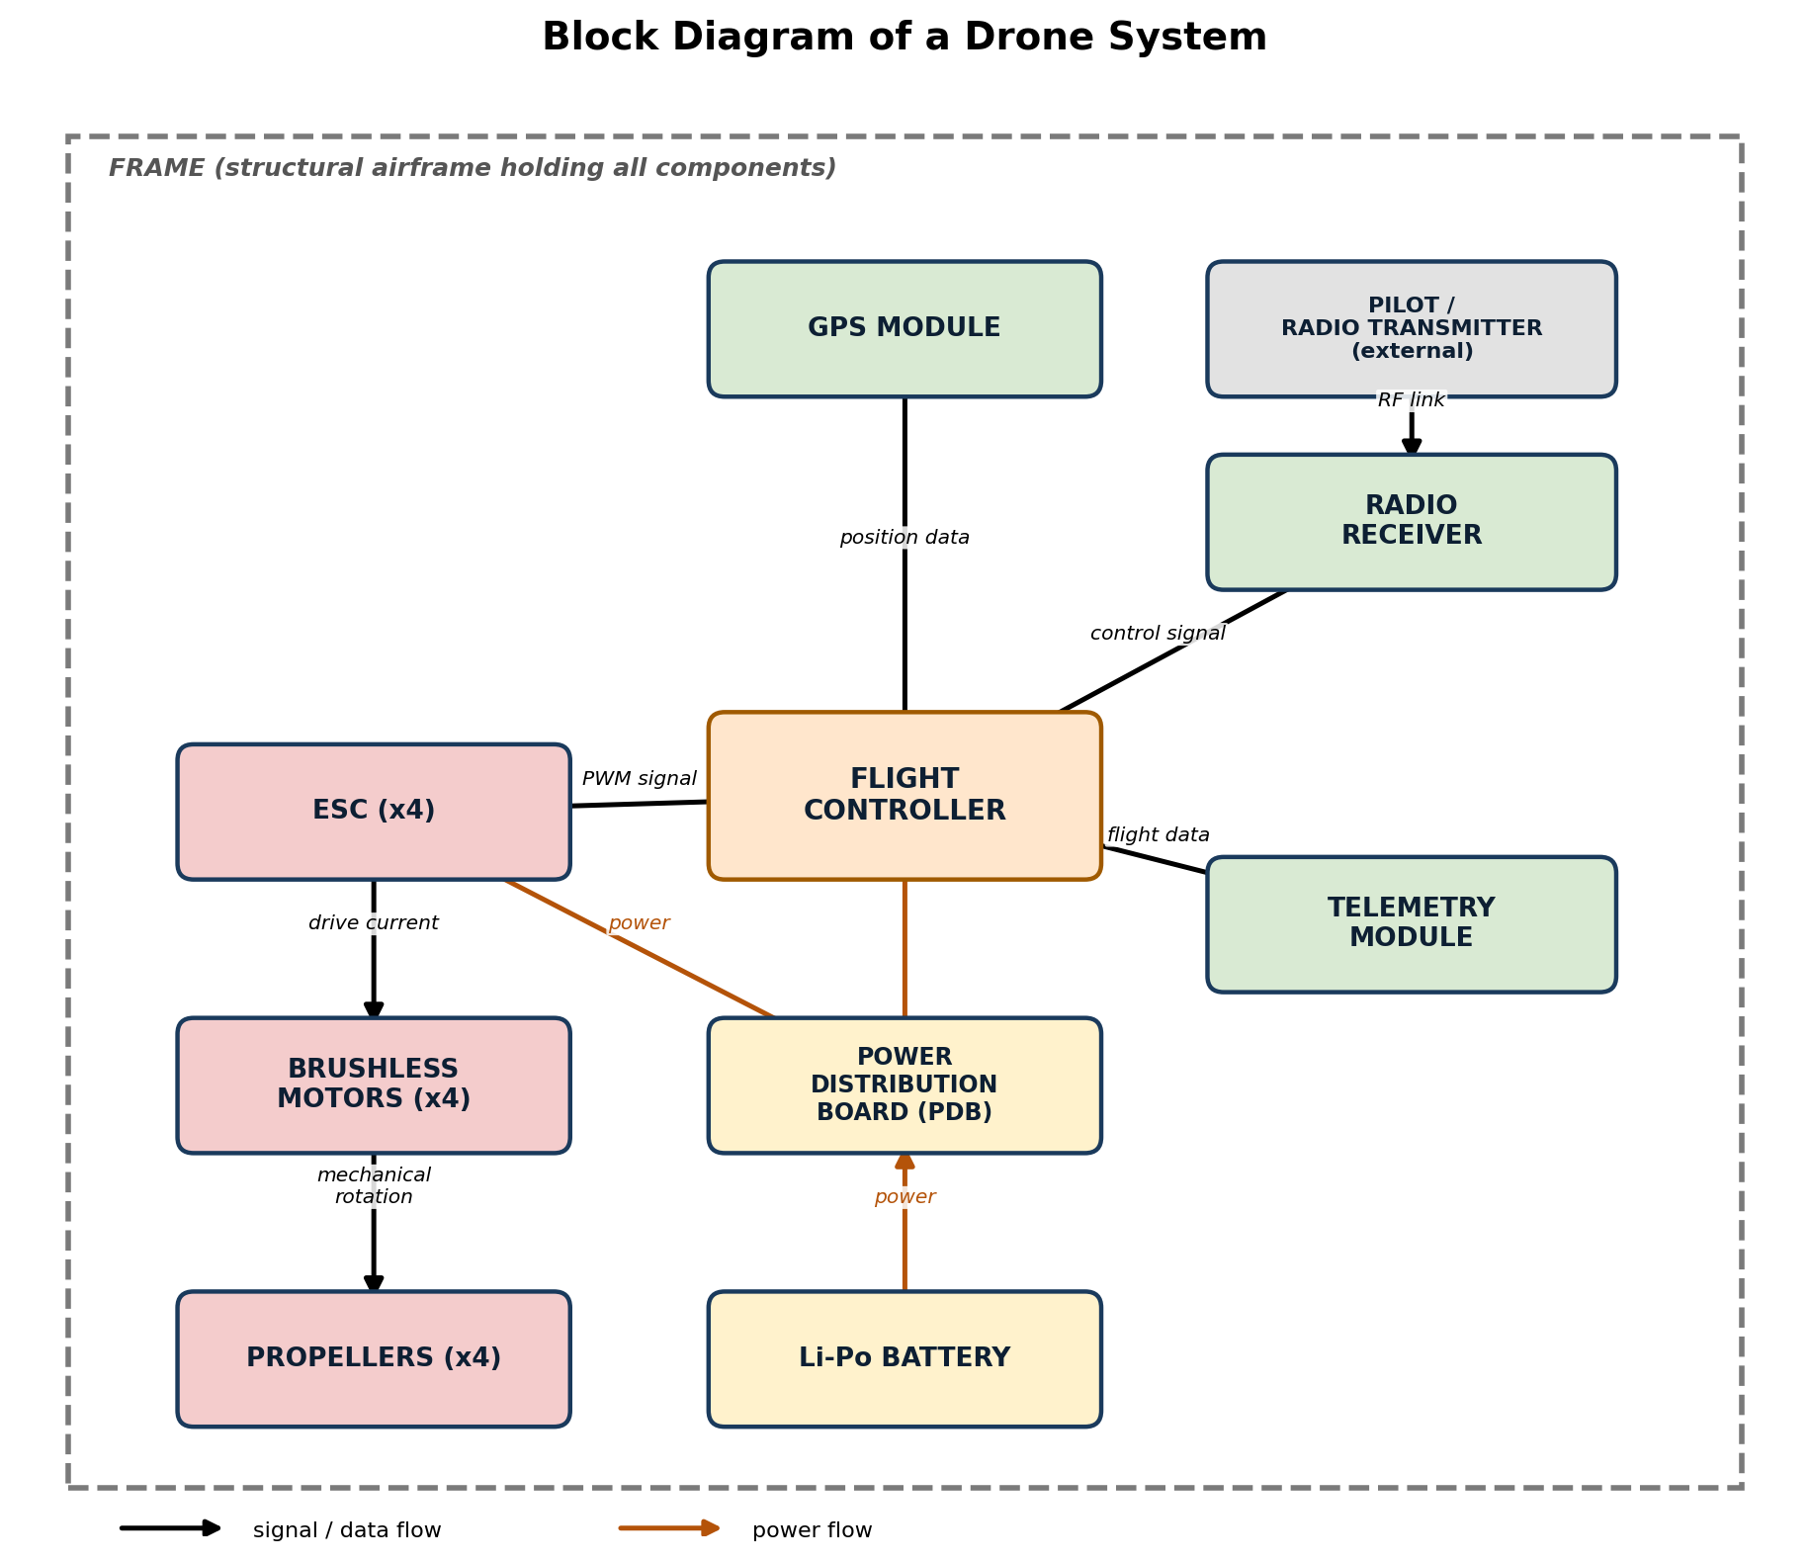
Fig. 6.1 — Block diagram of a drone system
Flight Controller (FC): The “brain” of the drone — an onboard computer with a built-in IMU that reads sensor data and pilot commands, runs the stabilization (PID) algorithm, and sends motor-speed commands to the ESCs.
ESC (Electronic Speed Controller): Converts battery DC power and the FC's low-current PWM signal into the higher-current 3-phase power that drives each brushless motor at the commanded speed.
Brushless (BLDC) Motors: Convert electrical energy into mechanical rotation to spin the propellers, offering higher efficiency and less wear than brushed motors.
Propellers: Airfoil-shaped blades that convert motor rotation into aerodynamic thrust by accelerating air downward.
Battery (Li-Po): Supplies electrical power to every component on board; Lithium-Polymer chemistry gives high energy density and high current output relative to its weight.
Power Distribution Board (PDB): Distributes battery power in parallel to all ESCs and other electronics from a single input.
GPS Module: Provides latitude, longitude, altitude and ground-speed data from navigation satellites, enabling waypoint navigation, position-hold and Return-to-Home.
Radio Receiver: Receives the RF control signal transmitted by the pilot's radio transmitter and passes the decoded channel data to the flight controller.
Frame: The mechanical skeleton/airframe that holds every component together and defines the drone's configuration (quad, hex, etc.) and durability.
Telemetry Module: A separate radio link that streams real-time flight data (battery voltage, GPS position, altitude, speed) down to a ground station, and can carry commands back up.

Q7. Explain the role of the following components. [10 Marks]
(Flight controller, ESC, BLDC motor, propeller, Li-Po battery, GPS, frame, and telemetry module play the same core roles described in Q6 above. Their roles are summarised again here for completeness, along with two additional components — the radio transmitter and the BEC.)
Flight Controller: Central decision-making unit; fuses sensor data and issues stabilised motor commands.
ESC: Regulates the power delivered to each motor to precisely control its rotational speed.
BLDC Motor: Generates the rotational force needed to spin the propeller and produce thrust.
Propeller: Translates rotational motion into aerodynamic thrust/lift.
Li-Po Battery: Acts as the single energy source powering flight, electronics and payload.
GPS: Gives the drone spatial awareness for autonomous navigation and position holding.
Radio Transmitter (TX): The handheld controller operated by the pilot; it encodes stick and switch movements (throttle, roll, pitch, yaw, flight-mode) into an RF signal broadcast to the onboard receiver.
Frame: Provides structural rigidity, mounting points, and protection for every other component.
Battery Eliminator Circuit (BEC): A small voltage regulator (built into an ESC or standalone) that steps the main battery voltage down to a stable 5V supply for the flight controller, receiver and other low-voltage electronics, removing the need for a separate receiver battery.
Telemetry Module: Keeps the ground operator informed of live flight status and can relay mission commands back to the drone.

Q8. Explain the working principle and application of key drone sensors. [10 Marks]
Sensor | Purpose | Working Principle | Application
IMU | Measures overall motion & orientation | Fuses accelerometer + gyroscope (and often magnetometer) data together | Core input to the flight-stabilisation (PID) algorithm
Accelerometer | Measures linear acceleration & tilt | A MEMS mass-spring structure changes capacitance as it deflects under acceleration | Detects tilt angle and vibration
Gyroscope | Measures angular (rotational) velocity | A MEMS vibrating structure senses the Coriolis force produced by rotation | Detects roll / pitch / yaw rate for stabilisation
Magnetometer | Measures Earth's magnetic field direction | Hall-effect / magnetoresistive sensing of field strength along 3 axes | Provides a compass heading reference to correct yaw drift
Barometer | Measures atmospheric pressure | A pressure-sensitive diaphragm deflects as pressure changes with altitude | Estimates altitude for altitude-hold mode
GPS | Determines absolute global position | Trilaterates position from timed signals of multiple navigation satellites | Waypoint navigation, position-hold, Return-to-Home
Optical Flow Sensor | Measures lateral movement close to the ground | A small downward camera + processor tracks pixel-pattern movement between frames | Stabilises hover indoors / in GPS-denied environments
Ultrasonic Sensor | Measures short-range distance | Emits an ultrasonic pulse and times the echo's return | Low-altitude height hold; short-range obstacle detection
LiDAR | Creates precise 3D distance maps | Emits laser pulses and measures the time-of-flight of reflected light | High-precision mapping, obstacle avoidance, terrain following
Camera | Captures imagery / enables vision-based navigation | An optical lens focuses light onto a CMOS image sensor | Photography & videography; computer vision (tracking, SLAM)

Q9. Compare the following sensor pairs. [5 Marks]
(a) GPS vs. Optical Flow
- GPS gives absolute global position using satellites; works outdoors with ~1–3 m accuracy but fails indoors or under cover.
- Optical Flow gives relative local position using a downward-facing camera; works well indoors/GPS-denied close to the ground, but needs good lighting and a textured surface, and its accuracy degrades at higher altitude.
(b) LiDAR vs. Ultrasonic
- LiDAR uses pulsed laser light, offers long range (hundreds of metres) with high accuracy and resolution in most lighting conditions, but is heavier and more expensive.
- Ultrasonic uses sound waves, has a short range (a few metres) and lower accuracy, but is cheap and lightweight; performance suffers on soft/absorbent surfaces and in windy/noisy conditions.
(c) Gyroscope vs. Accelerometer
- Gyroscope measures angular velocity (rate of rotation); very responsive but slowly drifts over time.
- Accelerometer measures linear acceleration and gravity direction, giving an absolute tilt reference, but is noisy under vibration. The two are fused together (as in an IMU) so each sensor corrects the other's weakness.

Q10. Explain the concept of 6 Degrees of Freedom (6DOF). [5 Marks]
6 Degrees of Freedom (6DOF) describes every independent way a rigid body such as a drone can move in three-dimensional space: three translational movements and three rotational movements.
Translation (movement along an axis, without changing orientation)
- X-axis — Surge: forward / backward movement.
- Y-axis — Sway: left / right (lateral) movement.
- Z-axis — Heave: up / down (vertical) movement.
Rotation (turning about an axis)
- About the X-axis — Roll: tilts the drone so one side dips and the other rises.
- About the Y-axis — Pitch: tilts the nose up or down.
- About the Z-axis — Yaw: rotates the drone about its vertical axis, changing heading.
A multirotor drone directly controls only four inputs — throttle, roll, pitch and yaw — yet by combining pitch/roll tilt with thrust it can also translate horizontally (surge/sway), so it effectively achieves full 6DOF motion from just four control channels.
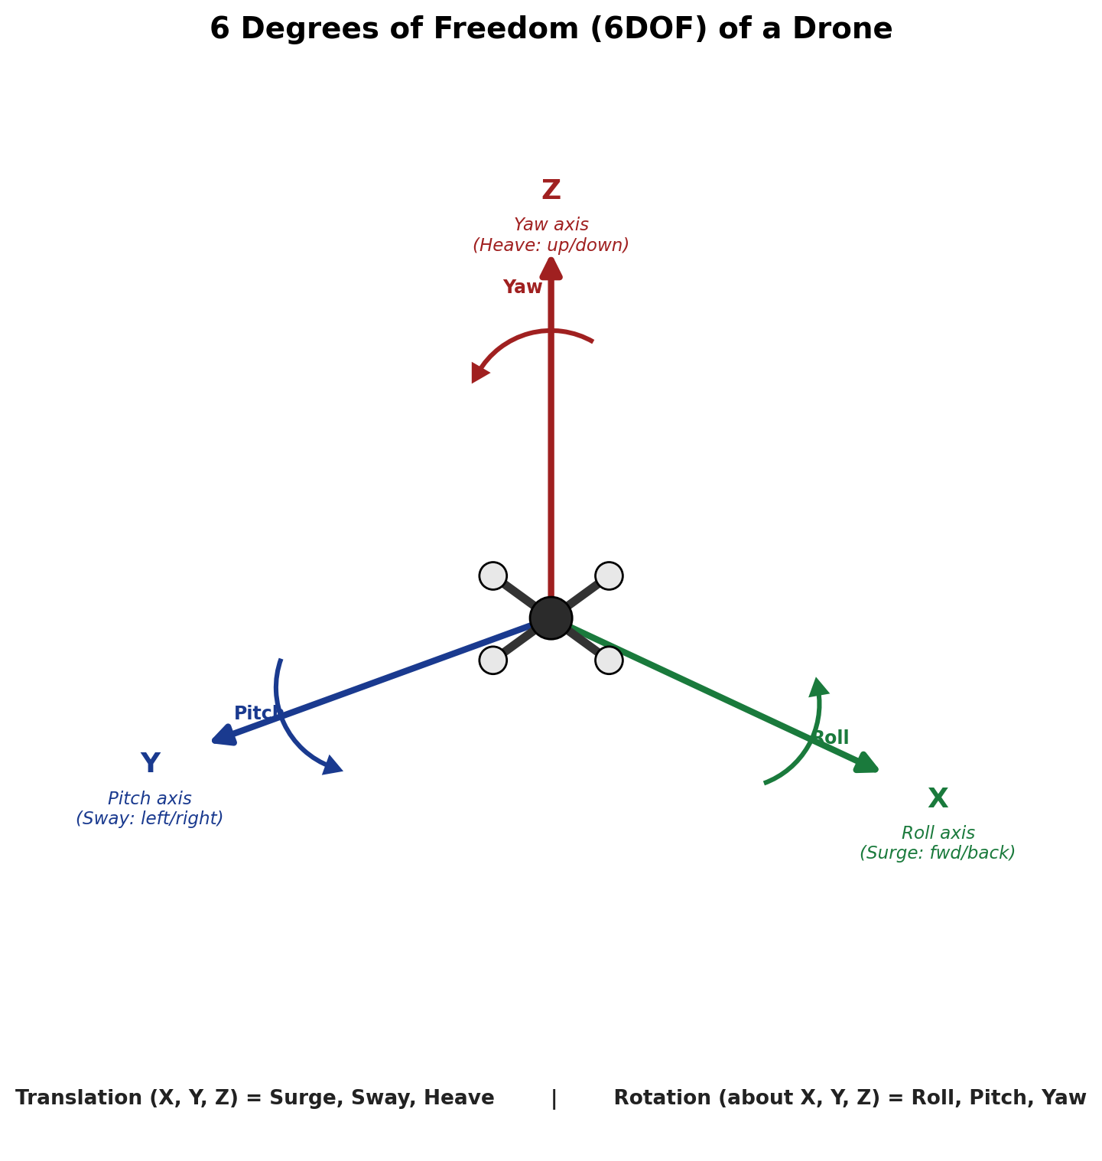
Fig. 10.1 — 6 Degrees of Freedom (6DOF) of a drone

Q11. Explain roll, pitch, yaw, surge, sway, and heave with examples. [10 Marks]
These six terms together make up the drone's 6DOF, illustrated in the diagram for Q10 above.
Term | Type | Axis | Example in a Drone
Roll | Rotation | X | Tilting sideways to bank into a turn or shift laterally, like leaning into a left turn
Pitch | Rotation | Y | The nose tips down to accelerate forward, or tips up to slow down or move backward
Yaw | Rotation | Z | Rotating on the spot to point the onboard camera at a new subject without changing position
Surge | Translation | X | Flying straight forward toward a target, e.g. approaching a delivery point
Sway | Translation | Y | Drifting sideways to avoid an obstacle such as a tree branch
Heave | Translation | Z | Climbing during take-off or descending gently to land

Q12. Explain the complete signal flow in a drone. [5 Marks]
1. Pilot Input: The operator moves the throttle, roll, pitch and yaw sticks on the handheld controller.
2. Radio Transmitter (TX): Encodes these stick positions into a digital RF control signal.
3. Radio Receiver (RX): Onboard the drone, demodulates the RF signal back into channel data.
4. Flight Controller (FC): Reads the receiver channels along with IMU/GPS sensor data, runs its PID stabilisation algorithm, and calculates the required speed for each motor.
5. ESC: Converts the FC's low-power PWM command for each motor into the higher-current 3-phase power needed to drive it.
6. BLDC Motors: Spin at the commanded RPM.
7. Propellers: Convert that rotation into aerodynamic thrust.
8. Drone Movement: The combined thrust from all propellers produces the drone's actual hover, climb, tilt or rotation, exactly as commanded by the pilot.
This entire loop repeats hundreds of times per second, letting the flight controller continuously correct for disturbances such as wind gusts.
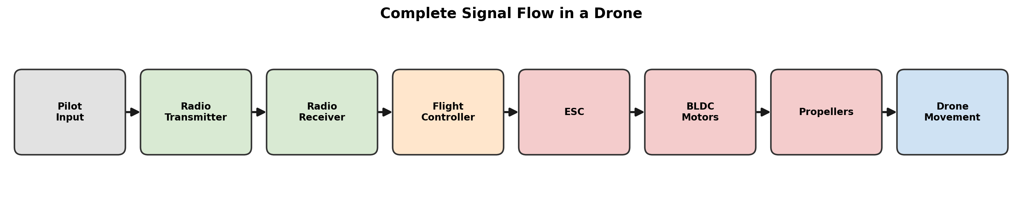
Fig. 12.1 — Complete signal flow in a drone

Q13. Why is PID control important in drones? [5 Marks]
A drone is inherently unstable — the smallest imbalance in thrust, or a gust of wind, will tip it over unless corrected many times per second. PID (Proportional-Integral-Derivative) control is the algorithm running on the flight controller that continuously compares the desired attitude (e.g., level flight, or a commanded tilt angle) with the actual attitude measured by the IMU, and instantly adjusts individual motor speeds to cancel any error. This closed-loop correction is what keeps a drone stable, level and responsive.
Proportional (P): produces a correction proportional to the current error (desired − actual). A larger error causes a stronger, immediate correction; too high a P gain causes oscillation and overshoot, while too low makes the drone sluggish.
Integral (I): accumulates past error over time to remove small steady-state errors that P alone cannot fix, such as a constant tilt from an off-centre battery or a mild breeze. Excessive I gain can cause slow oscillation (“wind-up”).
Derivative (D): reacts to the rate of change of the error, damping the response by predicting and countering overshoot before it happens, which keeps the correction smooth.
Together, P reacts quickly, I removes persistent bias, and D keeps the motion smooth — combining all three gives fast, stable, accurate flight control.
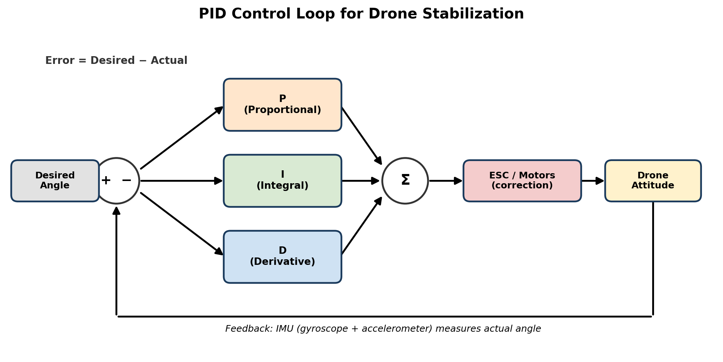
Fig. 13.1 — PID control loop for drone stabilisation

Q14. Bonus — Research Questions (any TWO). [10 Marks]
1. Compare DJI, ArduPilot, and PX4 flight controllers.
DJI: a closed-source, proprietary flight-control ecosystem built into DJI's own drones (Phantom, Mavic, Matrice, etc.). It is extremely polished and beginner-friendly, with strong built-in obstacle avoidance and a mature mobile app — but it is a “black box” that users cannot modify, and it only works with DJI's own hardware.
ArduPilot: a free, open-source flight-control software (the “ArduCopter” project and related firmware) that runs on many hardware boards, most commonly the Pixhawk family. It supports an unusually wide range of vehicle types — multirotor, plane, rover, boat, submarine — and is valued for its maturity, deep tuning options and large open community, though its ground-station software (Mission Planner / QGroundControl) is more technical than DJI's app.
PX4: another free, open-source flight-control stack, also commonly run on Pixhawk hardware, built with a modular, research- and industry-oriented software architecture. It is popular in academia and robotics research and integrates closely with ROS (Robot Operating System) for advanced autonomy work.
In short: DJI trades openness for polish and ease of use, while ArduPilot and PX4 trade some ease-of-use for being free, open-source, hardware-agnostic and highly customisable — ArduPilot is generally favoured for breadth of vehicle support, and PX4 for modular, research-grade autonomy.
2. How do drones return to home automatically?
Return-to-Home (RTH) is a safety fail-safe in which the drone autonomously flies back to a stored “home” GPS coordinate (normally recorded automatically at take-off, once a GPS lock is acquired) and lands, without pilot input. It is usually triggered automatically by a low battery warning, loss of the radio control signal beyond a timeout period, or loss of connection with the ground station, and can also be triggered manually by the pilot using a dedicated switch.
When triggered, the flight controller typically:
- Reads its current GPS position and compares it with the stored home position.
- Commands the drone to climb to a pre-set, safe RTH altitude to clear obstacles such as trees or buildings.
- Calculates a path back to home — a straight line on simple drones, or an obstacle-aware route on advanced models — and flies it using GPS-guided navigation.
- On arriving above the home point, initiates a controlled automatic descent and landing (or hovers, awaiting pilot takeover, on some systems).
Many modern drones also use onboard obstacle-avoidance sensors (ultrasonic, vision, or LiDAR) to detour safely around obstacles encountered along the RTH path.

Q15. Practical Activity — Hand Sketch of a Quadcopter. [10 Marks]
Chosen option: Create a 3D CAD model or hand sketch of a quadcopter, with every component labeled.
A reference labeled sketch is provided below as a starting template, with a numbered parts legend matching the diagram.
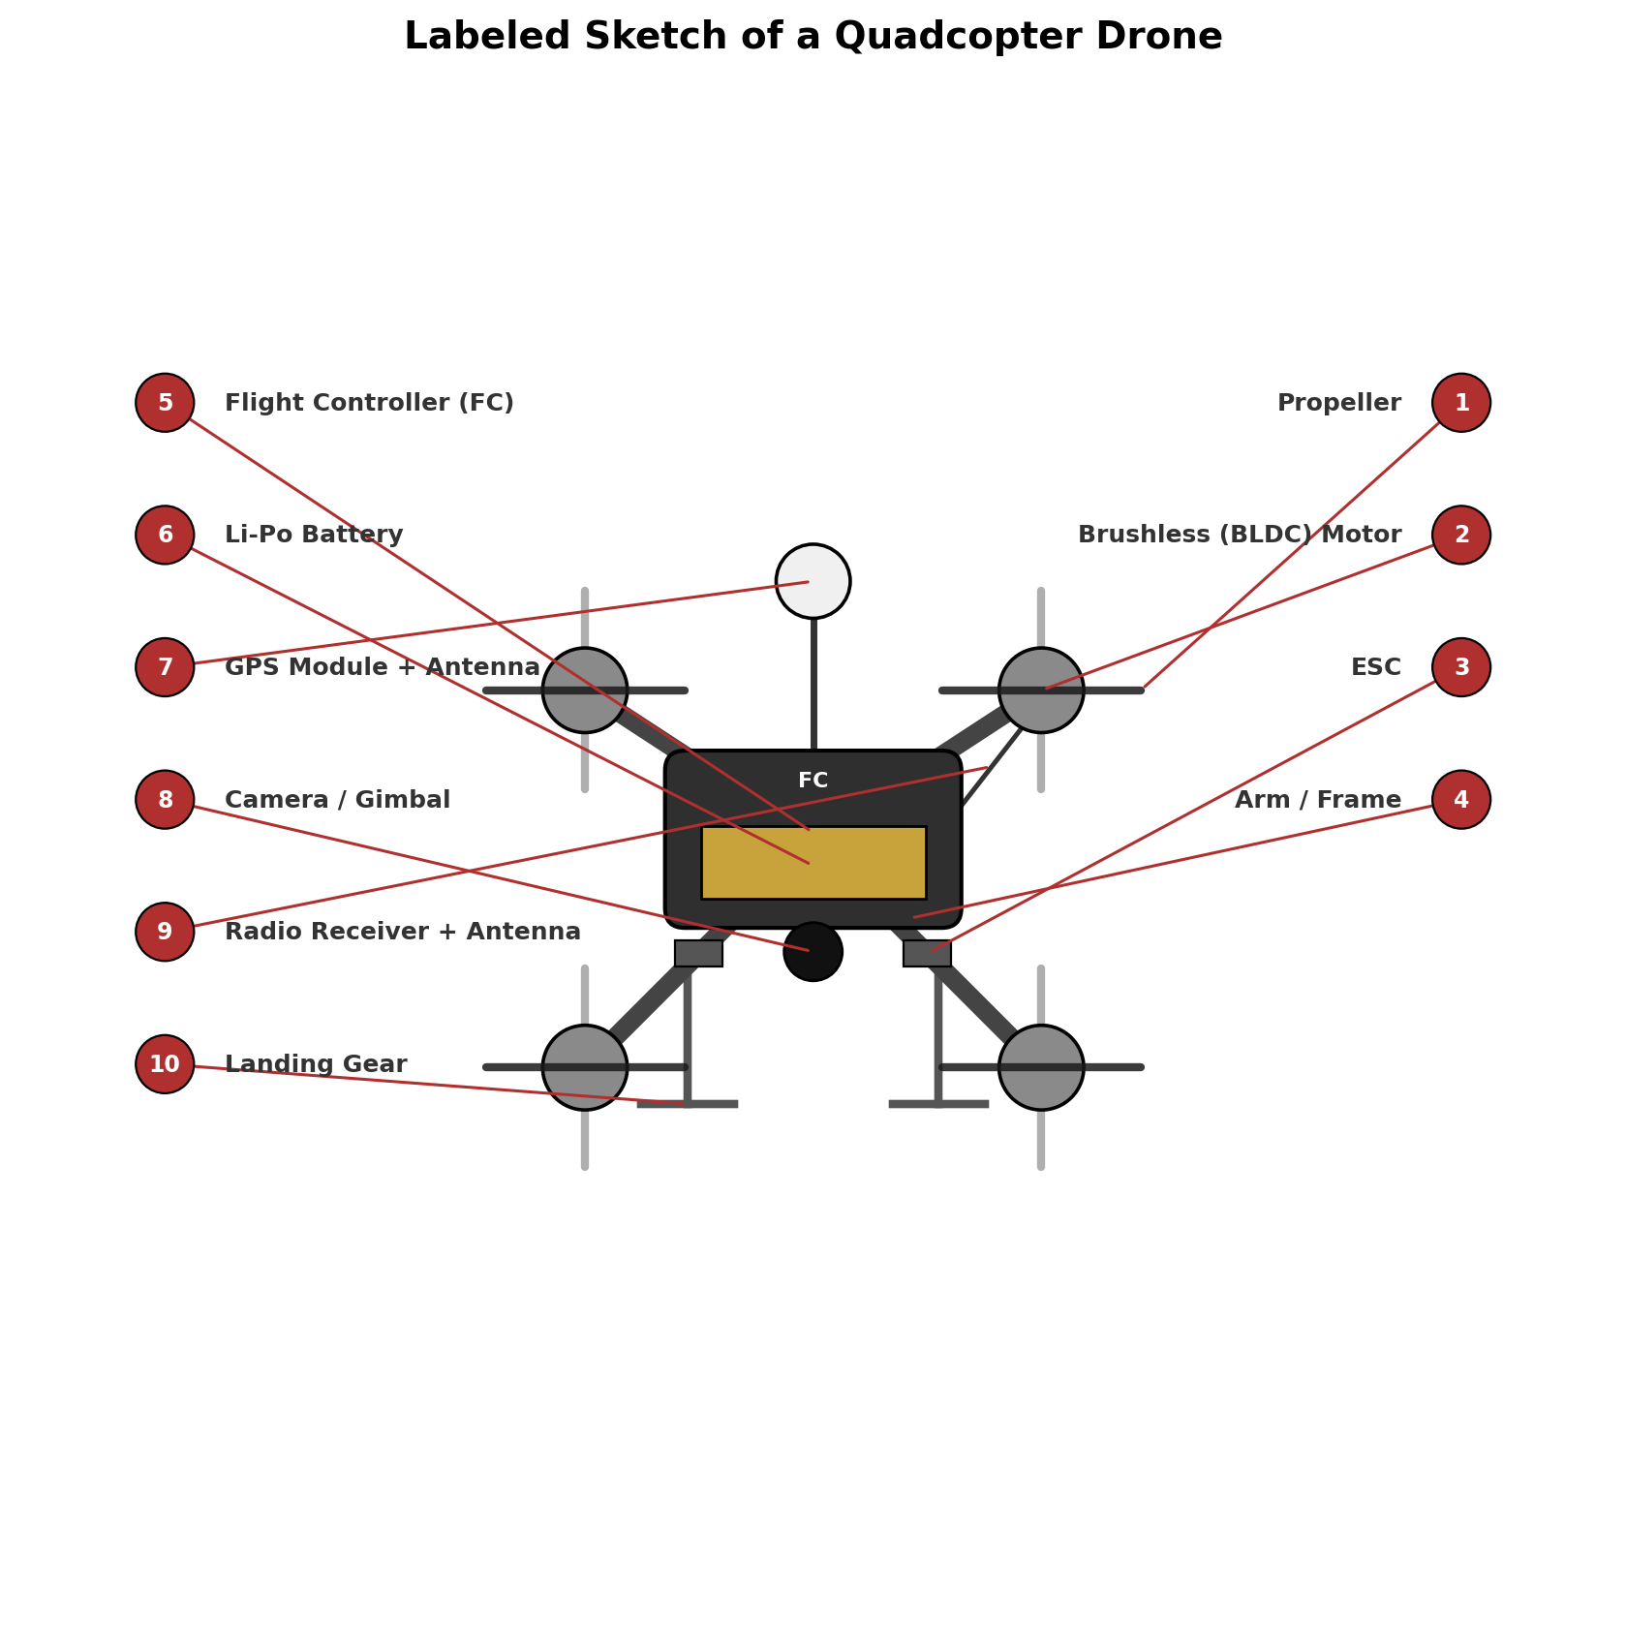
Fig. 15.1 — Labeled sketch of a quadcopter drone
Parts Legend
No. | Component | Function
1 | Propeller | Converts motor rotation into thrust
2 | Brushless (BLDC) Motor | Spins the propeller
3 | ESC | Controls motor speed
4 | Arm / Frame | Structural support connecting motors to the body
5 | Flight Controller (FC) | Onboard “brain” running stabilisation algorithms
6 | Li-Po Battery | Powers the entire aircraft
7 | GPS Module + Antenna | Provides position data for navigation
8 | Camera / Gimbal | Captures imagery / enables vision navigation
9 | Radio Receiver + Antenna | Receives pilot commands
10 | Landing Gear | Supports the drone at rest and absorbs landing impact

Higher-Order Thinking Questions
1. Why do quadcopters require four motors instead of one?
A single fixed-pitch rotor only produces thrust along one axis and creates a reaction torque that would spin the airframe uncontrollably unless countered — a single-rotor helicopter solves this with a mechanical swashplate and tail rotor. A quadcopter instead controls both attitude (pitch and roll, via differential thrust between opposite motors) and yaw (via the balance between the two CW and two CCW motors) purely by varying the RPM of four simple fixed-pitch propellers, without any moving mechanical linkages. Four is the minimum number of rotors that gives independent control over throttle, roll, pitch and yaw simultaneously.
2. What would happen if one motor stops working during flight?
On a standard four-motor quadcopter, losing one motor destroys both the thrust balance and the CW/CCW torque balance at the same time, so the frame flips and spins uncontrollably and the drone will crash, since there is no other motor pair left to compensate. Hexacopters and octocopters carry built-in redundancy: with six or eight motors, the flight controller can immediately re-balance the remaining motors to hold rough attitude and thrust, often allowing a controlled landing after a single motor failure.
3. Why are brushless motors preferred over brushed motors?
Brushless (BLDC) motors have no physical brushes or commutator rubbing against the rotor, so there is far less friction, heat, sparking and mechanical wear, giving them a much longer service life and higher reliability. They convert electrical energy to mechanical rotation more efficiently, deliver a better power-to-weight ratio, and can be spun at higher RPM with precise electronic commutation from the ESC — all of which directly improves a drone's flight time, payload capacity and thrust response.
4. Can a drone fly indoors without GPS? Explain.
Yes. GPS signals are usually blocked or too weak indoors, so the drone instead relies on other sensors for position-hold: an optical flow sensor (a downward-facing camera tracking ground texture) combined with an ultrasonic or barometric sensor for height gives it a local, GPS-free position and altitude reference, while more advanced platforms use visual-inertial odometry or SLAM with onboard cameras/LiDAR to build a map and localise within it. Without any of these aids, a skilled pilot can still fly indoors in pure manual mode, using the IMU alone for stabilisation and their own eyes for position.
5. Why are Li-Po batteries used in drones instead of standard batteries?
Lithium-Polymer cells pack a very high energy density and power density into a light, flexible package, and — critically — they can safely deliver the very high discharge current (measured by their “C” rating) that four motors demand under load, something standard alkaline or NiMH batteries cannot sustain. Their light weight relative to capacity directly extends flight time and payload capacity, which is why Li-Po (and increasingly Li-ion) has become the standard chemistry for drones despite needing careful charging and storage.
6. What factors reduce a drone's flight time?
Total aircraft weight (frame, battery size and especially payload) is the biggest factor, since heavier drones need more thrust and therefore more current at all times; strong wind, aggressive manoeuvring and repeated climbs also demand extra power beyond steady hover. Battery capacity, age/health and cold temperatures reduce the usable energy available, while aerodynamic drag, motor/propeller efficiency, and running extra payload electronics (cameras, lights, telemetry) all draw the battery down faster.
7. How can drone stability be improved during strong winds?
The PID gains (especially the Proportional and Derivative terms) can be tuned more aggressively so the flight controller reacts faster to gust-induced tilt, and GPS-based position-hold with wind/feedforward compensation helps the drone actively resist drift rather than only reacting after it has already moved. Physically, a heavier, more aerodynamic frame with a lower centre of gravity, well-balanced and vibration-damped IMU mounting, and simply avoiding flight beyond the aircraft's rated wind tolerance also significantly improve stability.
8. Why is sensor fusion important in drones?
No single sensor gives a complete, reliable picture of the drone's state: gyroscopes are very responsive but drift slowly over time, accelerometers give an absolute tilt reference but are noisy under vibration, and GPS gives absolute position but updates slowly and can drop out. Sensor fusion (typically via a Kalman filter combining the IMU, GPS, barometer and magnetometer) merges these complementary strengths and weaknesses into a single, smooth, accurate and drift-free estimate of position and attitude, which is essential for stable autonomous flight.
9. Explain how GPS and IMU work together for stable navigation.
The IMU (accelerometer + gyroscope) updates hundreds of times per second, giving the flight controller near-instant information about tilt and rotation rate so it can react to disturbances immediately — but because it works by integrating small measurements over time, its position estimate slowly drifts. GPS updates far less often (typically 5–10 times per second) but gives an absolute, drift-free position fix. An onboard filter (commonly an Extended Kalman Filter) fuses the two: fast IMU data drives smooth, high-rate control between GPS updates, while the periodic GPS fix corrects the accumulated IMU drift, giving navigation that is both responsive and accurate.
10. If you were designing a drone for mountain rescue operations, which sensors and components would you choose, and why?
For a mountain-rescue platform I would prioritise: a thermal/FLIR camera to spot the heat signature of survivors under vegetation or in low light; RTK-GPS for precise positioning even in signal-degraded mountainous terrain; a barometer and LiDAR/radar altimeter for reliable altitude-hold and terrain-following over changing elevation; and a long-range hexacopter or fixed-wing/VTOL hybrid airframe for endurance, payload capacity and motor redundancy, since a crash in a remote, inaccessible area is far more costly than in an urban setting. I would also include a long-range telemetry/radio link, onboard obstacle-avoidance sensors (given cliffs, trees and unpredictable downdrafts), a weatherproofed frame rated for cold and wind, a high-capacity battery or hybrid fuel system to maximise search time, and an optional cargo-drop mechanism to deliver emergency supplies to a located survivor.

Suggested References / Further Reading
The explanations above are based on standard UAV/aerospace engineering fundamentals. For deeper reading and verification, the following official resources are recommended:
- ArduPilot Documentation — https://ardupilot.org
- PX4 Autopilot User Guide — https://px4.io
- NASA Glenn Research Center, “Forces on an Airplane” — https://www.grc.nasa.gov
- Federal Aviation Administration, “Unmanned Aircraft Systems” — https://www.faa.gov/uas
- DJI Official Website (product & technology overviews) — https://www.dji.com

Note: please add any specific textbooks, lecture notes or articles you personally consulted, per the assignment's citation requirement.

